< Wallpaper & events calendar app for Omani Students Association at UMKC >

< Mohammed Al Hashemi >

< Omani Student at UMKC >

Revision History
Last User to make Changes | Date | Summary of Changes
Mohammed Al Hashemi | 01/4/18 | Initial Release
Mohammed Al Hashemi  Mohammed Al Hashemi | 2/19/18  3/4/2018 | Iteration#1  Iteration#2

Table of Contents
Vision Statement 4
Requirements 5
Step #1: Identify Categories of Users 5
Step #2: Create Actor-Goal List 5
Step #3: Identify User Stories 5
Product Backlog 6
[Step #4: Write Use Cases] 6
Sprint #1 7
Review 7
Retrospective 8
Sprint #2 10
Review 10
Retrospective 11
Sprint #3 14
Design 16
Coding Standards 17

Vision Statement

The goal of this project is to create an android application in order to help our association sharing and posting pictures of events that we host or participate in, along with a calendar of event and dates. The project will include wallpaper show in several ways such as grid view etc. and a menu of calendar of event in addition to links to our social media accounts.
This project will have the official logo of the association and some exclusive copyrighted photos. By using several features that android studio offers, we will be able to provide a good looking user interface and easy to explore app.
We aim to let other people know about our association and what kind of events that we have.
Product Name: MyWallpaper
Type: wallpaper & events app
Our association is supported by our government, so we need to show them an approval of work and events that we participate in to continue their funding.

Requirements

Step #1: Identify Categories of Users
Visitors – people who are interested in culture and diversity will have the opportunity to learn about Omani’s culture.
Admins – will be able to access and update the wallpaper and the calendar.
Volunteers – UMKC students who are interested in those event can participate.

Step #2: Create Actor-Goal List
Actor | Goal
Visitors | Browse wallpaper
 | Browse list of events
 | Have a knowledge about the association
 | Attend events by knowing the date and time
Sponsors | Will have approval of work
 | The ability to rate and report the quality of the events
 | Continue funding the association
Administrator | Publish and update the wallpaper and list of events
 | Provide all the requirement and features listed above

Step #3: Identify User Stories

As a developer of this app, I aim to provide the flexibility of accessing the features that we offer in the app. So that will benefit our association by having more subscriber or people of interest.

Allow visitor to explore and save photos from the wallpaper + seeing the calendar of events
Estimated Effort: 12 Story Points
While visiting the wallpaper, visitor should have the ability to browse the gallery smoothly.

Product Backlog

Story ID | Story | Story Points | Priority | Status
S1 | Allow visitors/users to run the app | 4 | 2 | cp
S2 | Allow visitors/ sponsors to browse and save the photo at wallpaper, and see the calendar of events | 16 | 3 | pr
S3 | As a developer I would like to build a nice UI and easy access app with no issue. Simple and unique at the same time. | 12 | 1 | pr
S4 | Reviewing and debugging the app in order to guaranteed the quality. | 8 | 4 | pr

[Step #4: Write Use Cases]
At the end of developing this application both users and admins will have the smoothly access to the app features with no debugging errors. By each sprint, I will express what are the features that I am going to add and the details or running, coding, and designing time spent.

Sprint #1
Before you can plan a sprint you need a prioritized list of user stories (the product backlog). Factors to consider when prioritizing stories include [Cohn, Agile Estimating and Planning]:
- Business value of feature
- Cost of implementation (story points or ideal days)
- Amount and value of new knowledge gained by developing the feature
- Risks resolved as a consequence of implementing the feature

Another important step in sprint planning is estimating project velocity. Project velocity is a measure of how much work is being completed each iteration (sprint). It is usually expressed using the same unit of measure used to estimate story effort (typically story points). For the first iteration, project velocity must be estimated based on past projects. After the first iteration, project velocity can be predicted based on the completed iterations.

The Sprint Backlog identifies stories planned for the sprint along with tasks necessary to complete each story.

Sprint Backlog
Story ID | Story / Task | Estimated  Hours | Actual  Hours
S3 | Create new project | 1 | 1
 | Design UI | 2 | 1
 | Determine external file format | 2 | 1
 | Code writing | 2 | 1
 | Code fixing | 2 | 3
 | Write automated unit tests | 2 | 1
 | Build array for wallpaper photos | 2 | 1
 | Manage codes for photos size and layout | 3 | 2
 | Add app icon | 2 | 1
 | Reviewing and seeing the overall result | 6 | 4

Review

Retrospective

For this iteration, I was planned to complete two stories. I completed almost both of them, but I had a problem with changing the application icon which cause me delay and less time management. However, everything else worked as I planned to.

Project velocity:
14 , because I need more work on the interface.

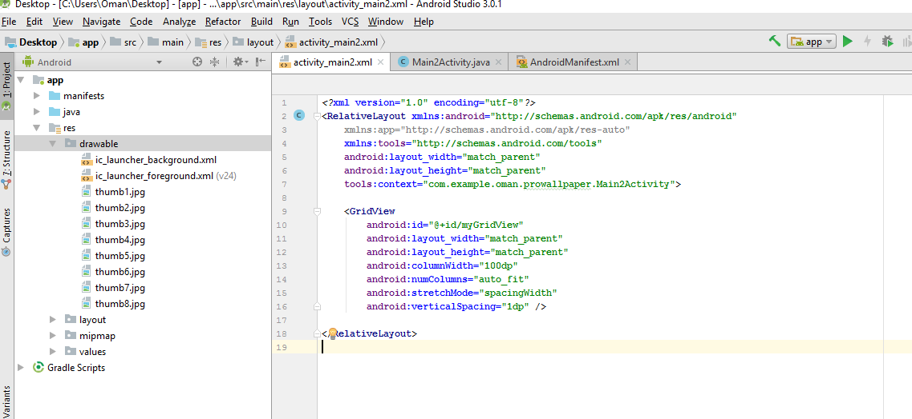
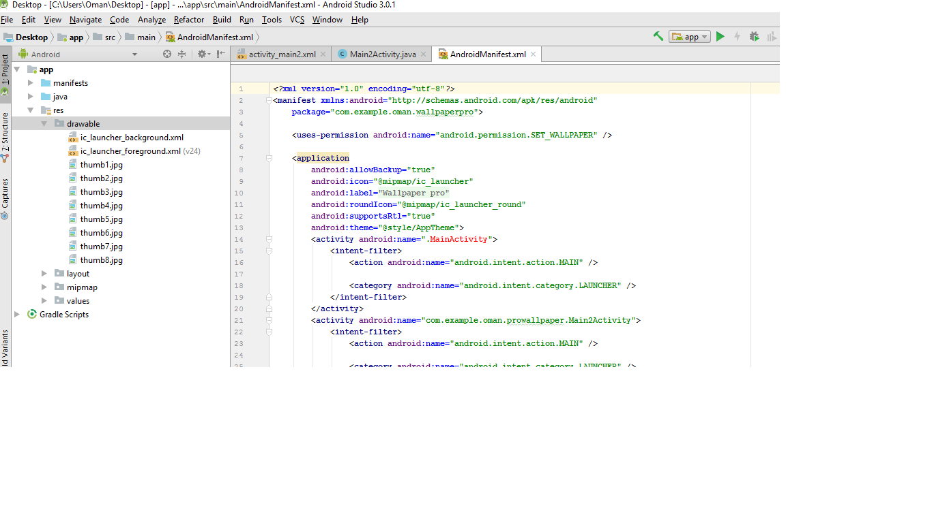

Sprint #2

In the next sprint, I will be working on the interface. In addition to that, I will add more features such as images grid view and make them visible. Also, I might add the menu button to add more features on the next sprints.

Sprint Backlog
Story ID | Story / Task | Estimated  Hours | Actual  Hours
S1 | Improve UI | 2 | 3
 | Add features | 5 | 3
 | Errors handling | 2 | 2
 | Extra coding | 3 | 2
 | Testing | 1 | 1

Review
At the end of this Iteration I was able to complete all the parts that I planned to work in during sprint 1 and 2. Also, I had an improvement on error handling. By the end of this iteration, the time I spent on coding and error handling been finally minimized. As an overall, working on this iteration has been successfully done.

Retrospective

For this iteration, I was planned to complete two stories. I completed the entire stories that I planned to and the once that I left from previous iteration.

Here are some screenshots of the work:

- Working on the code. Specially the main activity

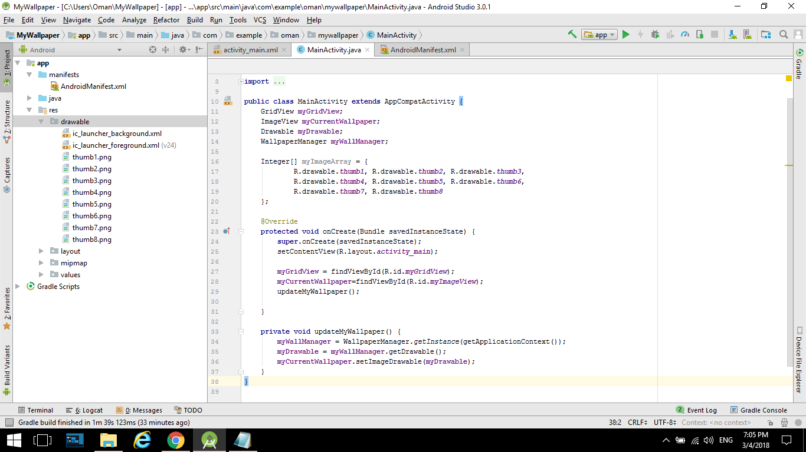

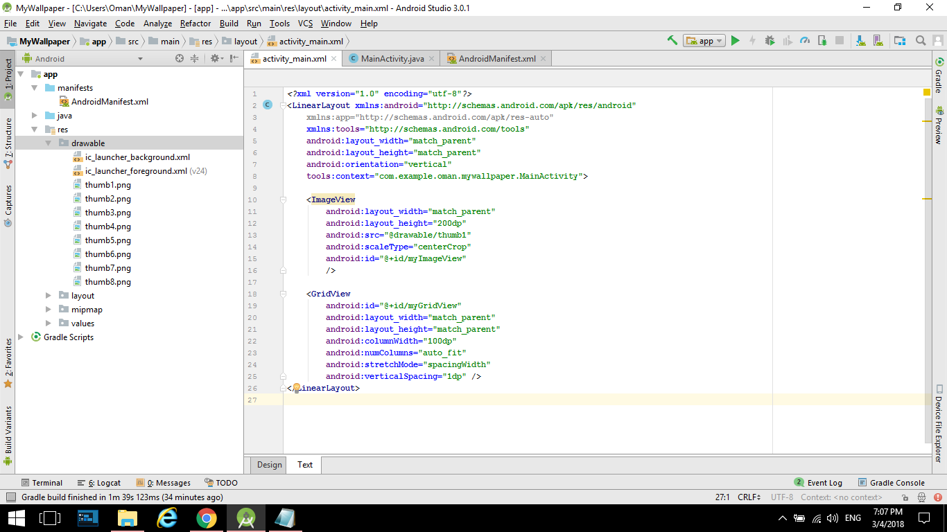

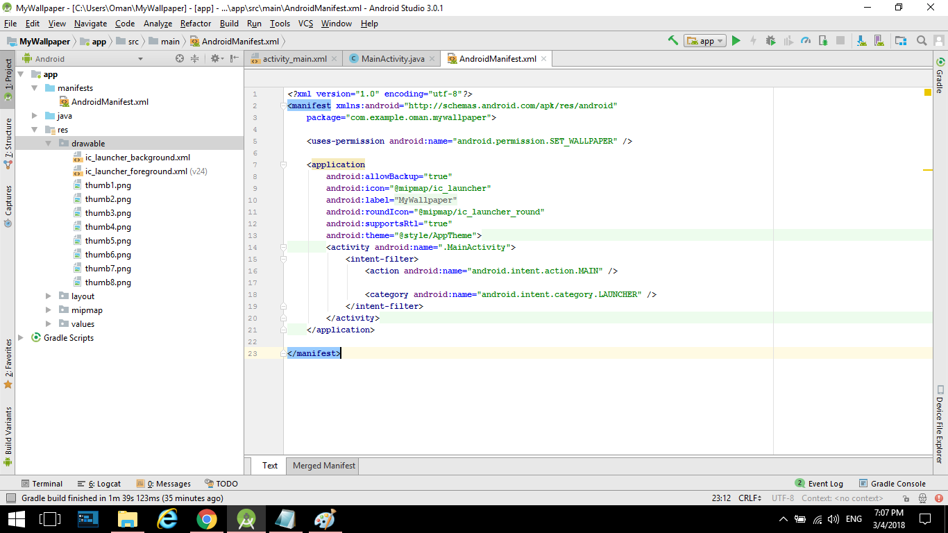

- Working on the design and layout:

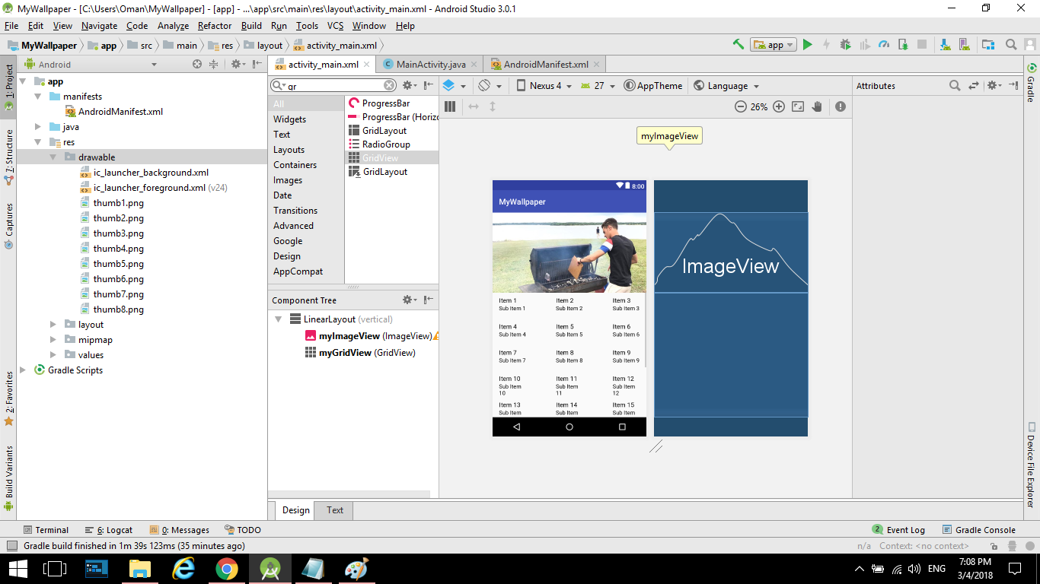

- Changing the app Icon:



*Note: working on GitHub is not working well with me, until I pass through this issue I will be uploading a zip file of the project along with this document.

Sprint #3

On the next iteration, I will be adding more feature to the application. I will add specially an adaptor that will make the app able to do the functionality of both image and grid view. This will work along with the image array that already coded on the previous 2 iterations. After that the plan is to add a splash screen that user will be able to see when they first time open the app.
Sprint Backlog
Story ID | Story / Task | Estimated  Hours | Actual  Hours
S1 | Maintain the previous Iterations | 1
S2 | Add more features | 4
 | Improving the layout | 3
 | Error handling | 2
 | Overall measuring | 1

Design

The overall structure of this project is to build an app that make it easy for us to access our photo gallery along with event schedule. By going step by step (moving from iteration to another) it will be valuable to see what else we can add to the app.

Coding Standards
Coding standards improve readability. They make it easier to understand code written by others. Good coding standards also improve reliability.

